|  |
| --- |
| Cybersecurity |
| Penetration Test Report |

Rekall Corporation

Penetration Test Report

# 

## 

## Confidentiality Statement

This document contains confidential and privileged information from Rekall Inc. (henceforth known as Rekall). The information contained in this document is confidential and may constitute inside or non-public information under international, federal, or state laws. Unauthorized forwarding, printing, copying, distribution, or use of such information is strictly prohibited and may be unlawful. If you are not the intended recipient, be aware that any disclosure, copying, or distribution of this document or its parts is prohibited.

Table of Contents

Confidentiality Statement 2

Contact Information 4

Document History 4

Introduction 5

Assessment Objective 5

Penetration Testing Methodology 6

Reconnaissance 6

Identification of Vulnerabilities and Services 6

Vulnerability Exploitation 6

Reporting 6

Scope 7

Executive Summary of Findings 8

Grading Methodology 8

Summary of Strengths 9

Summary of Weaknesses 9

Executive Summary Narrative 10

Summary Vulnerability Overview 13

Vulnerability Findings 14

# 

## 

## Contact Information

|  |  |
| --- | --- |
| **Company Name** | Red Pill |
| **Contact Name** | Muhammad Shakeel |
| **Contact Title** | Penetration Testing Expert |

## 

## Document History

|  |  |  |  |
| --- | --- | --- | --- |
| **Version** | **Date** | **Author(s)** | **Comments** |
| 001 | 5/2/2024 | Muhammad Shakeel | Day One |

# 

## 

## Introduction

In accordance with Rekall policies, our organization conducts external and internal penetration tests of its networks and systems throughout the year. The purpose of this engagement was to assess the networks’ and systems’ security and identify potential security flaws by utilizing industry-accepted testing methodology and best practices.

For the testing, we focused on the following:

* Attempting to determine what system-level vulnerabilities could be discovered and exploited with no prior knowledge of the environment or notification to administrators.
* Attempting to exploit vulnerabilities found and access confidential information that may be stored on systems.
* Documenting and reporting on all findings.

All tests took into consideration the actual business processes implemented by the systems and their potential threats; therefore, the results of this assessment reflect a realistic picture of the actual exposure levels to online hackers. This document contains the results of that assessment.

### Assessment Objective

The primary goal of this assessment was to provide an analysis of security flaws present in Rekall’s web applications, networks, and systems. This assessment was conducted to identify exploitable vulnerabilities and provide actionable recommendations on how to remediate the vulnerabilities to provide a greater level of security for the environment.

We used our proven vulnerability testing methodology to assess all relevant web applications, networks, and systems in scope.

Rekall has outlined the following objectives:

Table 1: Defined Objectives

|  |
| --- |
| **Objective** |
| Find and exfiltrate any sensitive information within the domain. |
| Escalate privileges. |
| Compromise several machines. |

# 

## 

## Penetration Testing Methodology

### Reconnaissance

### 

We begin assessments by checking for any passive (open source) data that may assist the assessors with their tasks. If internal, the assessment team will perform active recon using tools such as Nmap and Bloodhound.

### Identification of Vulnerabilities and Services

We use custom, private, and public tools such as Metasploit, hashcat, and Nmap to gain perspective of the network security from a hacker’s point of view. These methods provide Rekall with an understanding of the risks that threaten its information, and also the strengths and weaknesses of the current controls protecting those systems. The results were achieved by mapping the network architecture, identifying hosts and services, enumerating network and system-level vulnerabilities, attempting to discover unexpected hosts within the environment, and eliminating false positives that might have arisen from scanning.

### Vulnerability Exploitation

Our normal process is to both manually test each identified vulnerability and use automated tools to exploit these issues. Exploitation of a vulnerability is defined as any action we perform that gives us unauthorized access to the system or the sensitive data.

### Reporting

Once exploitation is completed and the assessors have completed their objectives, or have done everything possible within the allotted time, the assessment team writes the report, which is the final deliverable to the customer.

# 

## 

## Scope

Prior to any assessment activities, Rekall and the assessment team will identify targeted systems with a defined range or list of network IP addresses. The assessment team will work directly with the Rekall POC to determine which network ranges are in-scope for the scheduled assessment.

It is Rekall’s responsibility to ensure that IP addresses identified as in-scope are actually controlled by Rekall and are hosted in Rekall-owned facilities (i.e., are not hosted by an external organization). In-scope and excluded IP addresses and ranges are listed below.

# 

# 

## 

## Executive Summary of Findings

## 

### Grading Methodology

Each finding was classified according to its severity, reflecting the risk each such vulnerability may pose to the business processes implemented by the application, based on the following criteria:

**Critical**: Immediate threat to key business processes.

**High**: Indirect threat to key business processes/threat to secondary business processes.

**Medium**: Indirect or partial threat to business processes.

**Low**: No direct threat exists; vulnerability may be leveraged with other vulnerabilities.

Informational: No threat; however, it is data that may be used in a future attack.

As the following grid shows, each threat is assessed in terms of both its potential impact on the business and the likelihood of exploitation:

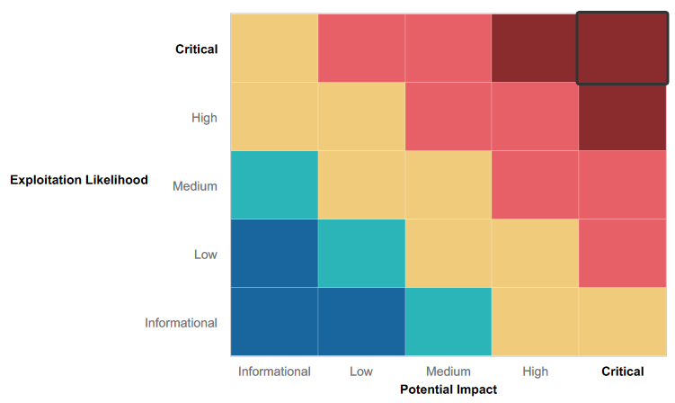

### 

### 

### Summary of Strengths

While the assessment team was successful in finding several vulnerabilities, the team also recognized several strengths within Rekall’s environment. These positives highlight the effective countermeasures and defenses that successfully prevented, detected, or denied an attack technique or tactic from occurring.

* Availability of Multiple servers.
* Password policies.
* Web App is hosted in a Docker Container.

### Summary of Weaknesses

We successfully found several critical vulnerabilities that should be immediately addressed in order to prevent an adversary from compromising the network. These findings are not specific to a software version but are more general and systemic vulnerabilities.

**Web Application Vulnerabilities**

* SQL Injection Vulnerability
* File Inclusion Vulnerability
* PHP Injection Vulnerability
* XSS Vulnerability

**Linux Servers Vulnerabilities**

* Weak Passwords
* Allowing traffic through open ports
* Outdated Software

**Windows Servers Vulnerabilities**

* Unnecessary scheduled tasks
* Publicly available credentials
* Allowing traffic through open ports

## 

## Executive Summary

**Web Application pentesting summary**

1. When initially analyzing the Web App for Rekall Corporation, Red Pill was able to access sensitive information by using XSS Scripting.

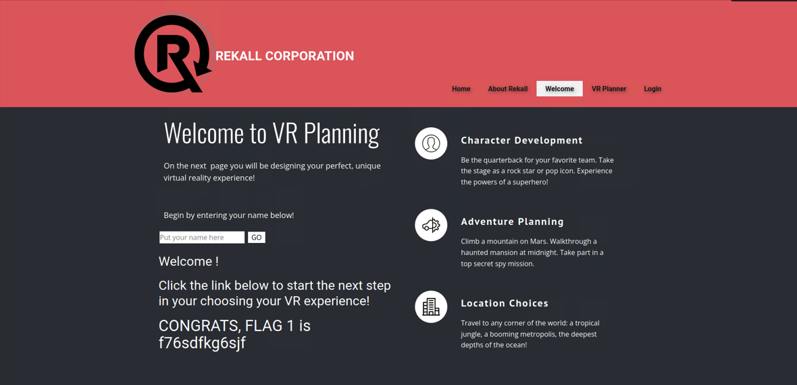

2. Further, Red Pill came across a field which was filtering for the word script. By reassembling the words to negate this filter, Red Pill was able to further access sensitive information using XSS Scripting.



3. Red Pill found an option to upload a file to the Web App. The field filtered for a jpg file but Red Pill was able to avoid this remediation by putting jpg in the filename and uploading the malicious script to reveal sensitive information.

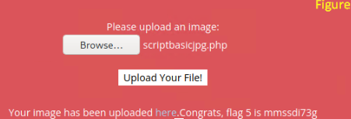

4. Using a basic SQL Injection attack in the username & passwords field, Red Pill was able to access sensitive information.

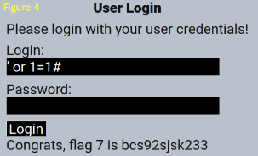

5. Using curl against the Web App, Red Pill was able to find sensitive information in the HTML cleartext of the Web App.

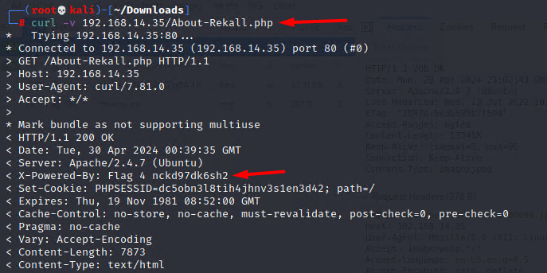

6. Red Pill was able to find user credentials for **dougquaid** by opening page source and inspecting the HTML cleartext for the login page.

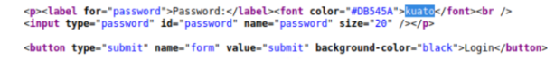

7. Red Pill was able to view a hidden file in the Web App and access sensitive information.

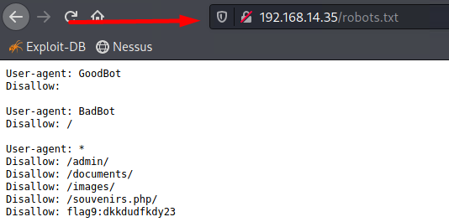

8. Red Pill was able to execute BASH commands into the DNS Check field by using a simple exploit. Using these commands Red Pill was able to access and view sensitive information in the file **vendors.txt**.

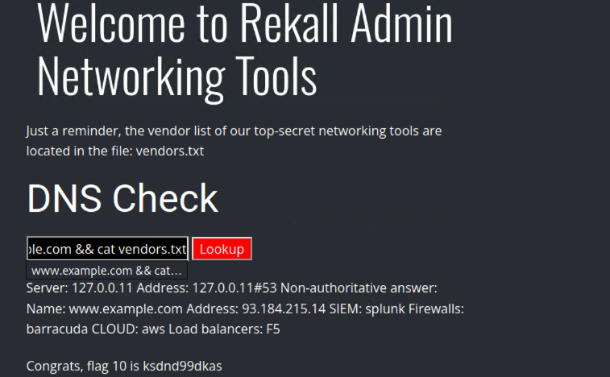

9. Using the previous exploit, Red Pill was able to discover a username **melina** with an easily guessable password same as the username. Using these new credentials, Red Pill was able to log in to the Web App and access sensitive information.

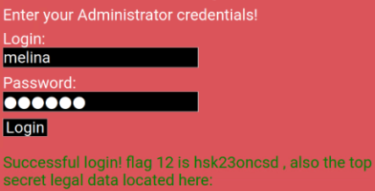

10. Using Burp Suite to send multiple HTTP requests, with different session ID to **/admin_legal_data.php** page of the Web App, Red Pill was able to hijack cookie session of another user to log in as **Admin** and access sensitive information.

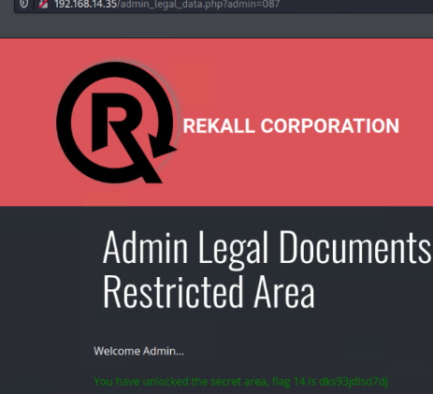

11. Red Pill was able to traverse through directories by changing the link and accessing files not present to the public. These files could be found by simple BASH commands used in previous exploits.

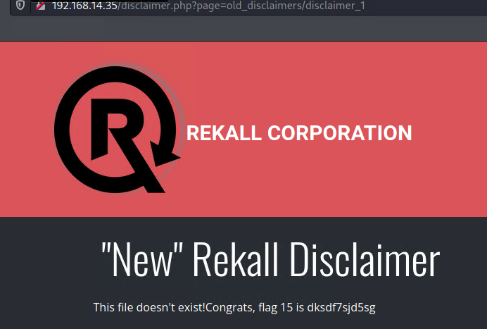

**Linux Servers pentesting summary**

1. Red Pill started the Initial recon by using Domain Dossier Tool to find sensitive information for the domain name **totalrekall.xyz.**

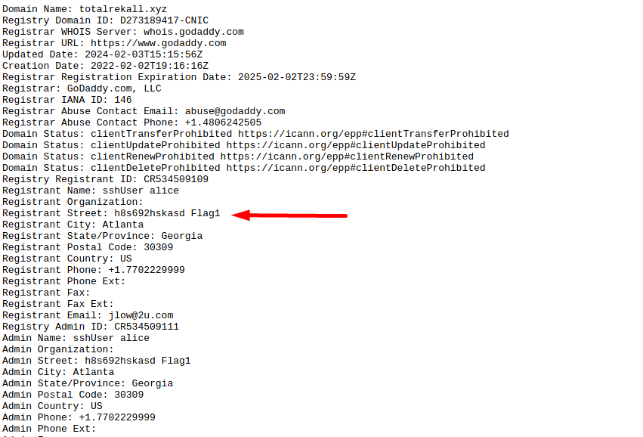

2. Red Pill then looked up DNS records using the same tool, against the domain name **totalrekall.xyz** and found sensitive information in the TXT records.

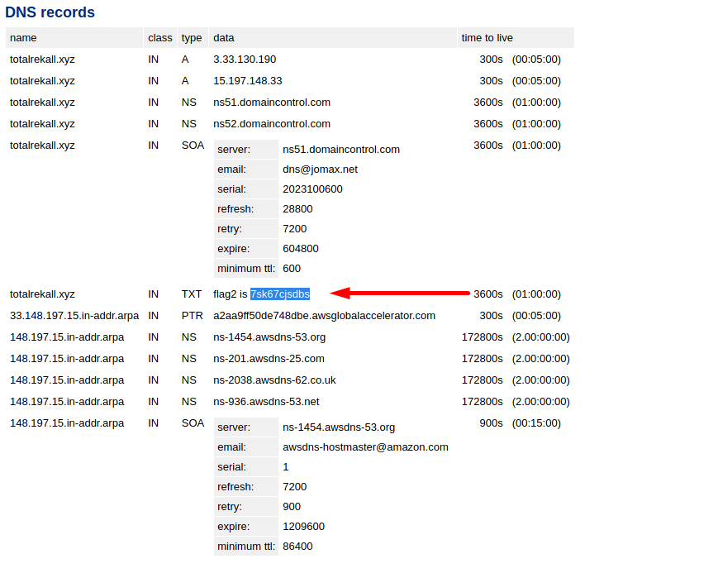

3. Red Pill ran a certificate search against the domain name **totalrekall.xyz**, using the tool crt.sh and found what certificates the domain was running.

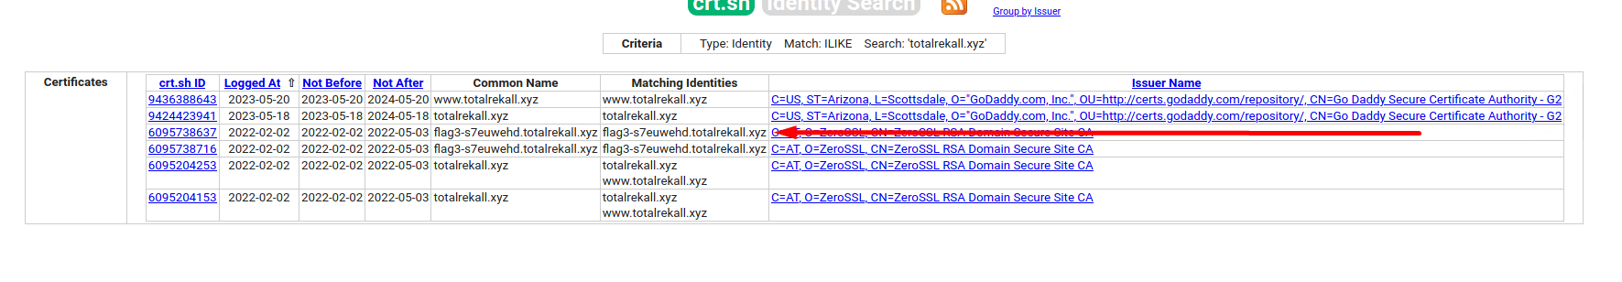

4. Red Pill ran a nmap scan against the Rekall network **192.168.13.0/24** and found how many hosts were in the network.

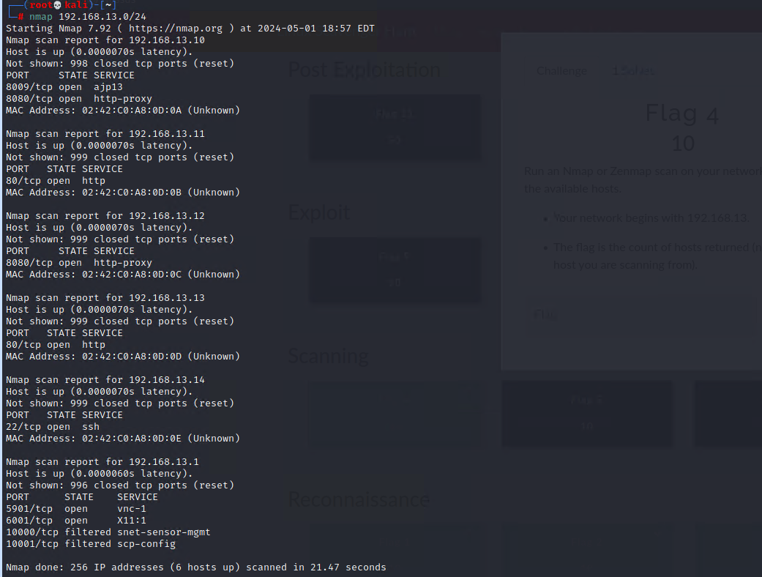

5. Red Pill then ran an aggressive nmap scan against the Rekall network and found the IP address of the host that was running Drupal.

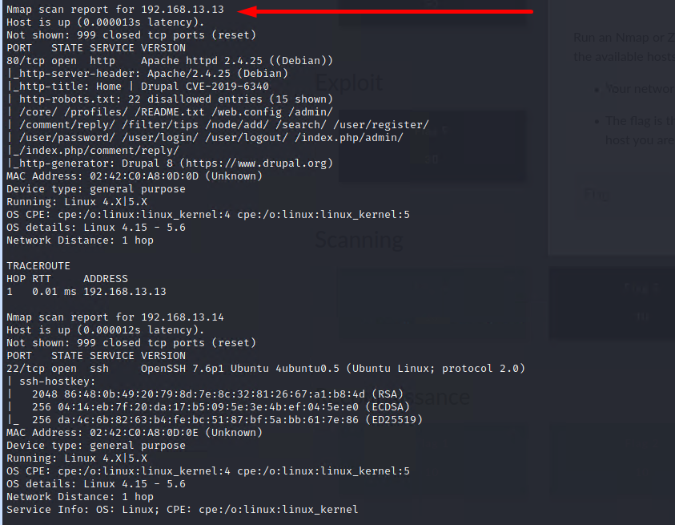

6. Red Pill ran a nessus scan against the host **192.168.13.12** and found a critical vulnerability with the system.

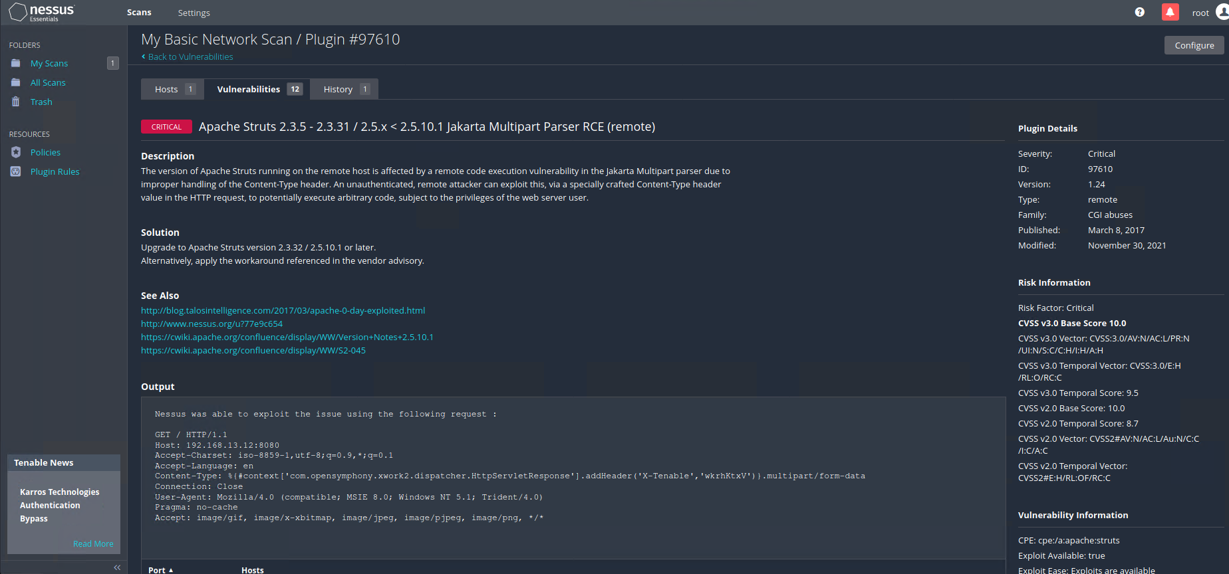

7. Red Pill ran an aggressive scan against the host **192.168.13.10** and found information regarding the ports and what version they are running.

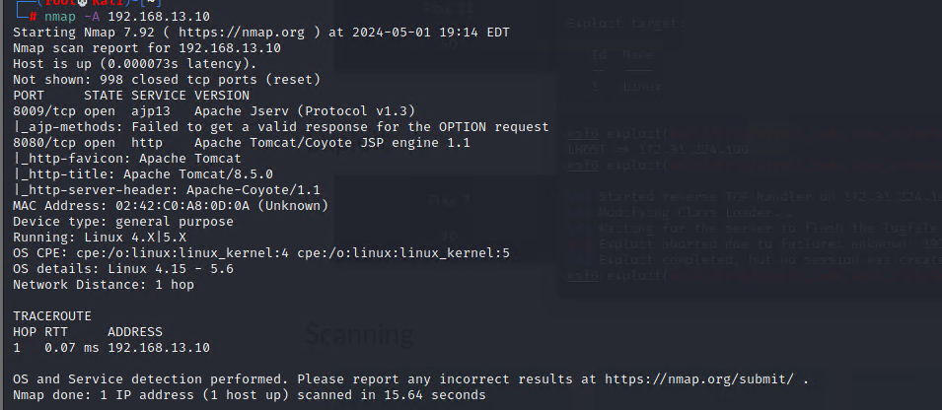

8. Using metasploit to exploit the open port **8080** on the host **192.168.13.10**, Red Pill was able to gain shell and find sensitive information.

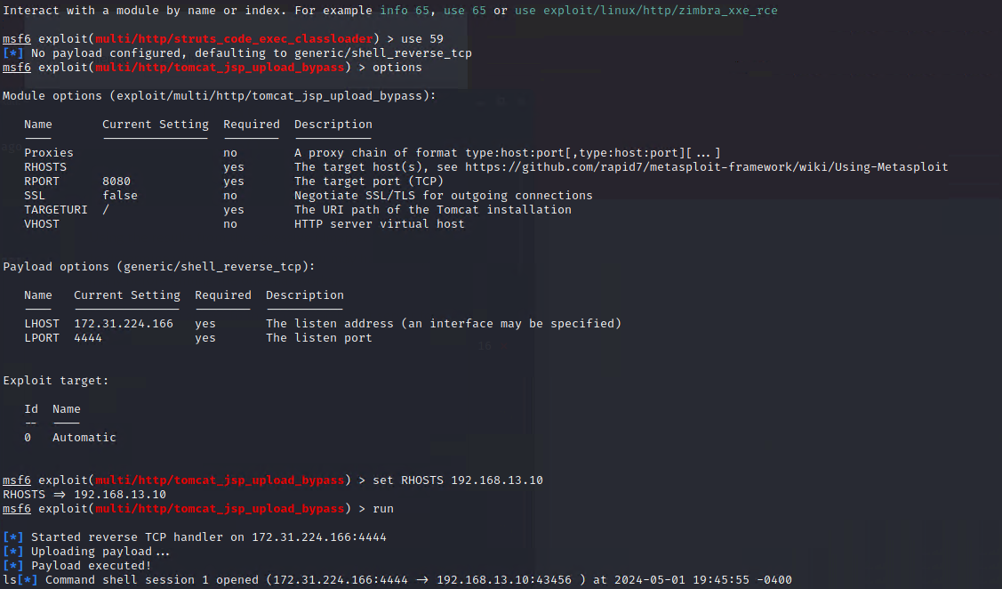

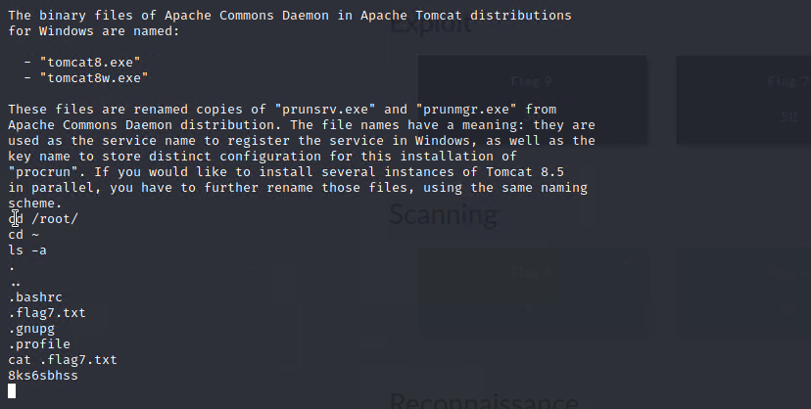

9. Red Pill ran an aggressive scan against the host **192.168.13.11** and found information regarding the ports and what version they are running. Using metasploit to exploit the host on port **80**, Red Pill was able to gain shell and find information regarding sudo permissions.

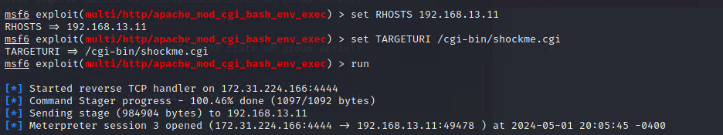

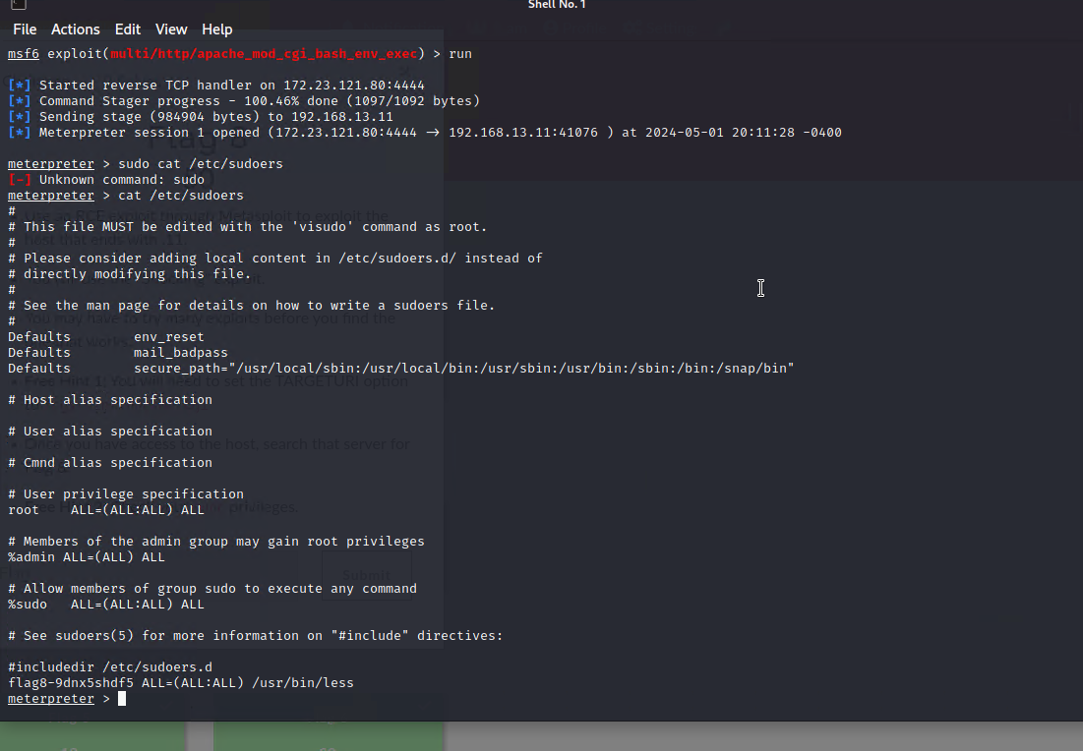

10. Red Pill ran an aggressive scan against the host **192.168.13.12** and found information regarding the ports and what version they are running. Using metasploit to exploit the host on port **8080**, Red Pill was able to gain shell and find information regarding users passwords.

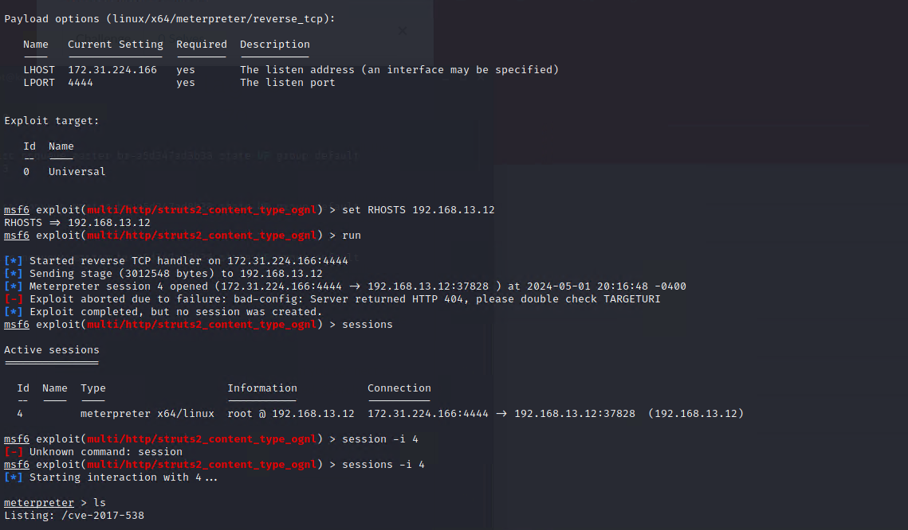

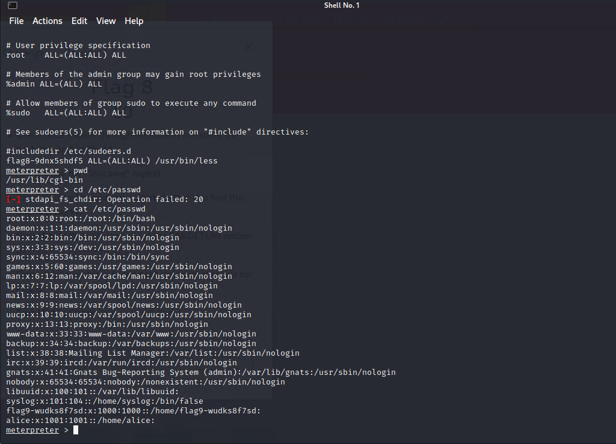

11. Red Pill ran an aggressive scan against the host **192.168.13.13** and found information regarding the ports and what version they are running. Using metasploit to exploit the host on port **80**, Red Pill was able to gain shell and find sensitive information.

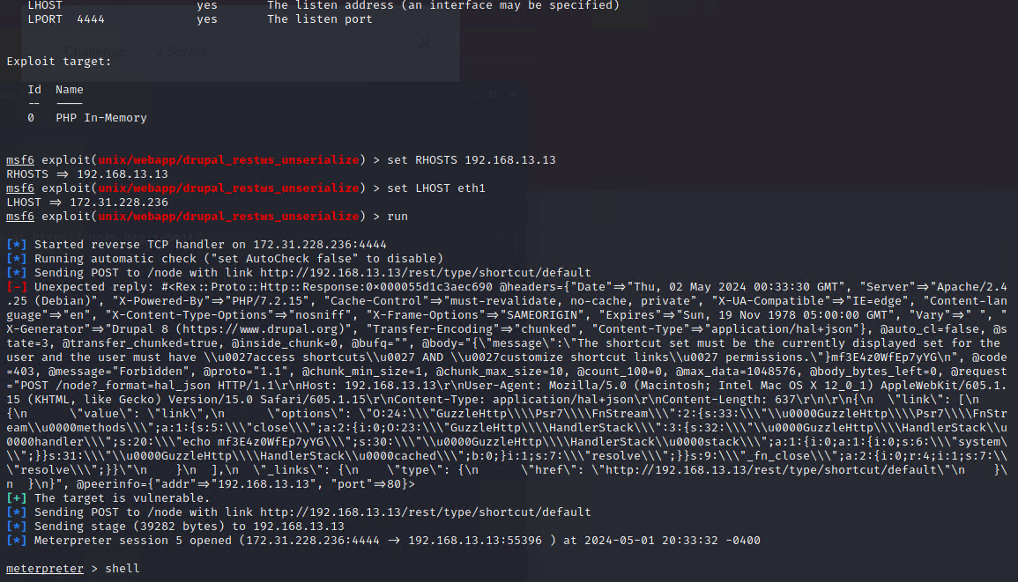

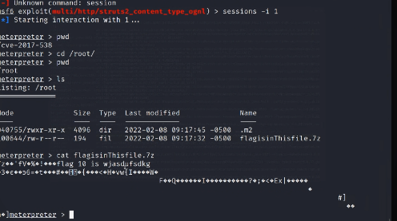

12. Using the name found in the initial Domain Dossier recon (**alice**), Red Pill was able to ssh into the host **192.168.13.14** using the username **alice** and an easily guessable password which was the same as the username. Red Pill was able to use a privilege escalation exploit to view sensitive data.

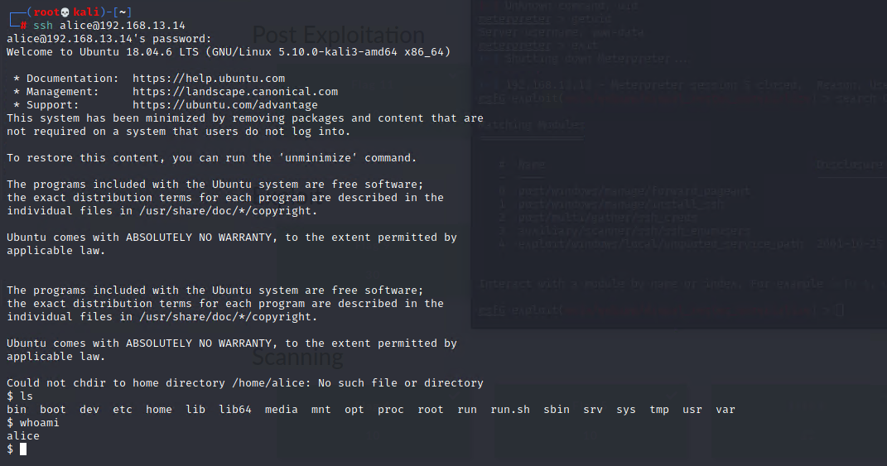



**Windows Servers pentesting summary**

1. Red Pill was able to look up the GitHub Repository for TotalRekall through google.

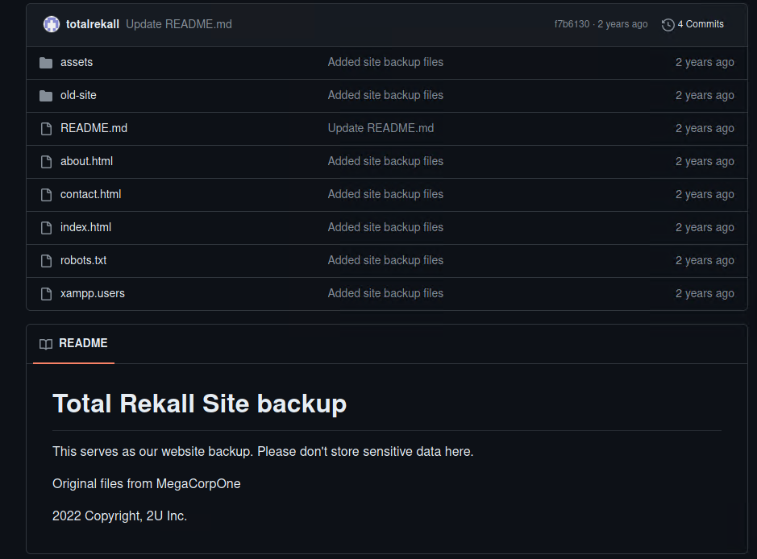

2. Red Pill was able to find a file named **xampp.users** on the GitHub repository and when opened, the file contained username and password hash.

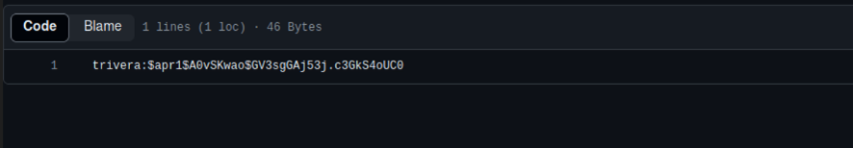

3. Red Pill was able to find a sensitive file on the host **172.22.117.20**. This was achieved by logging in to the website using the credentials found in the **xampp.users** file. The password hash was cracked by a simple dictionary attack which returned Tanya4life.

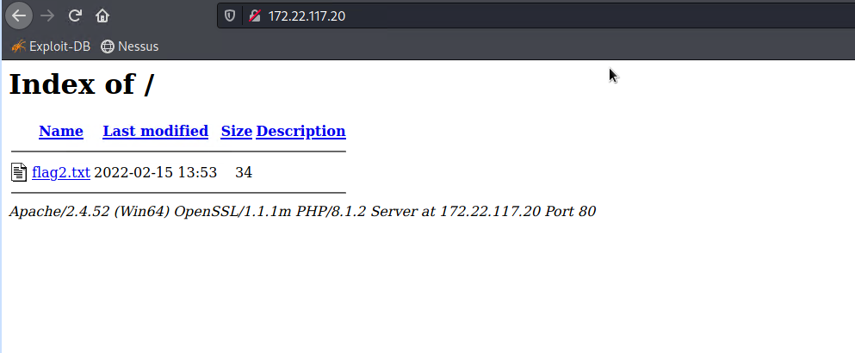

4. Red Pill then ran an aggressive NMAP scan against the host **172.22.117.20.**

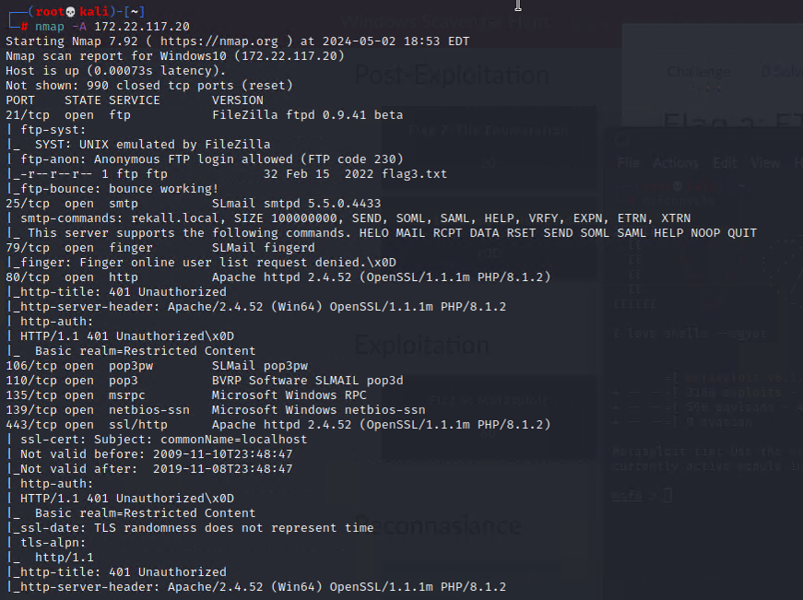

5. Red Pill found an ftp service with the version *FileZilla ftpd 0.9.41 beta* running on the open port **21.** Using this exploitable version Red Pill was able to log in to the machine as anonymous and was able to access sensitive information.

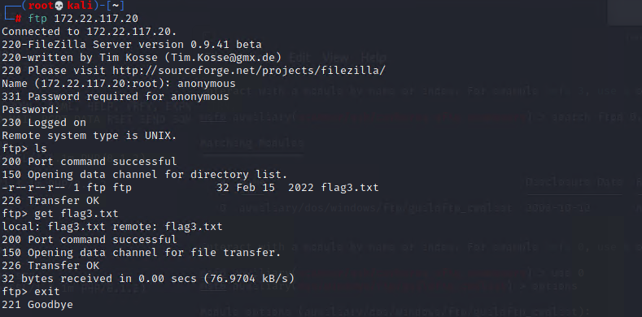

6. On the same host, Red Pill was able to find an open port **106** running **SLmail pop3w**.

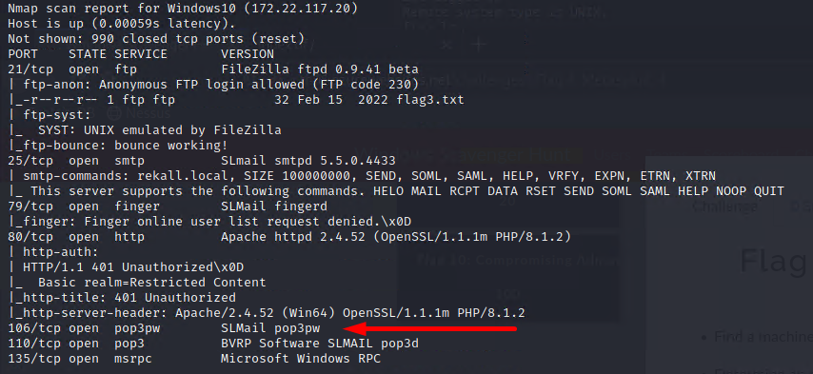

7. Using metasploit to exploit this vulnerable port version, Red Pill was able to gain a meterpreter session to the host 172.22.117.20 and gain access to sensitive information.

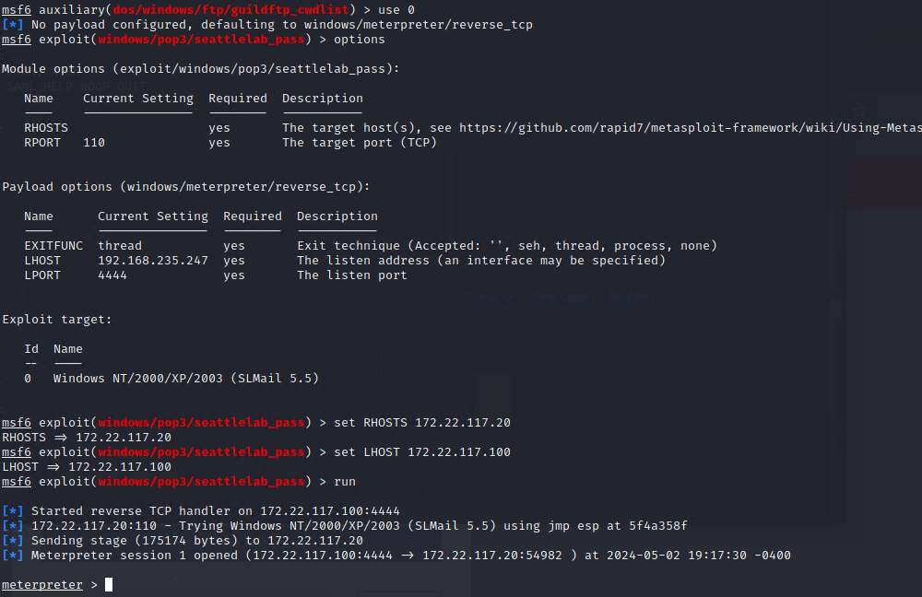

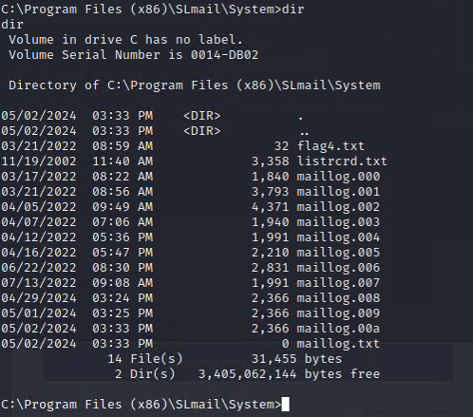

8. On the same host, Red Pill was able to find an unnecessary scheduled task.

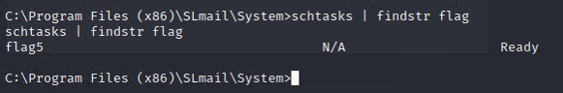

9. Using a KIWI Module, Red Pill was able to find MsCacheV2 hash for the user **ADMBob.**

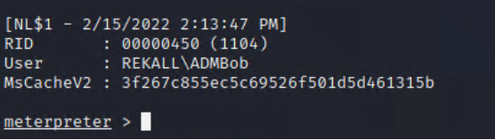

10. Red Pill then used john the crack the hash for the user ADMBob.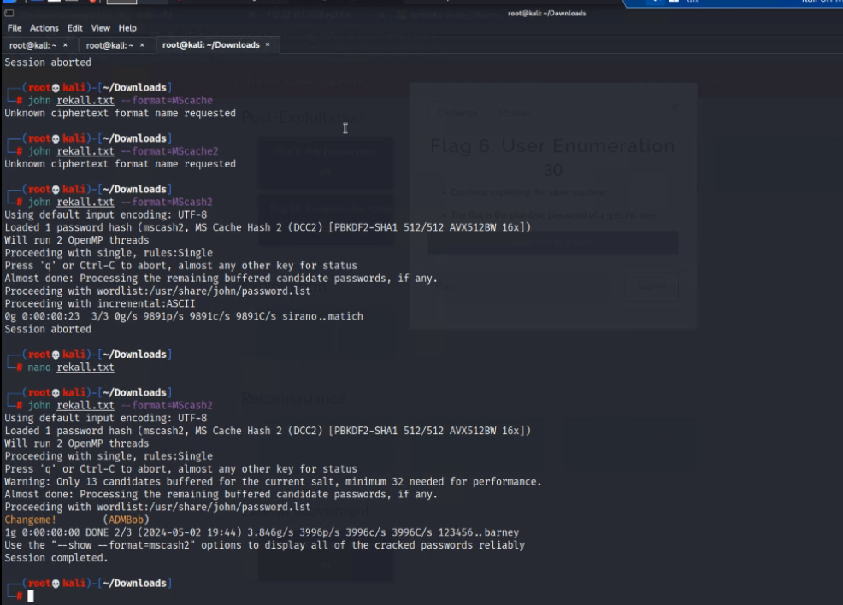

11. Red Pill also found information regarding another user running on the same host 172.22.117.20 and using KIWI, Red Pill was able to find the NTLM hash for the user.

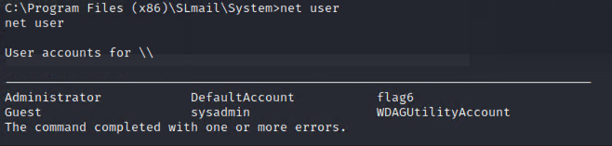

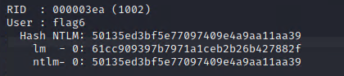

12. Red Pill was able to further find a file containing sensitive information in the **Documents** folder.

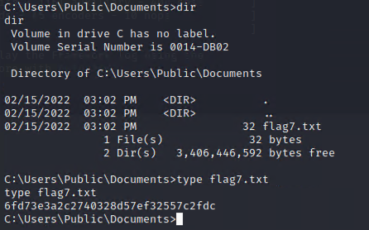

13. Red Pill was then able to laterally move from the Win 10 host (**172.22.117.20**) to Windows Domain host (**172.22.117.10**) using metasploit and the credentials found previously for ADMBob. After gaining meterpreter session to the host **172.22.117.10** Red Pill was able to find information regarding current users on the host.

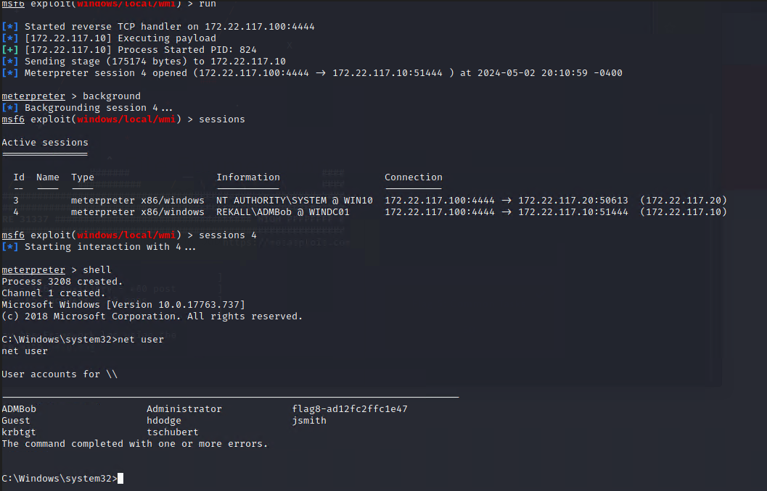

14. Red Pill was then able to move into C:\ Drive to the host **172.22.117.10** and find a file containing sensitive information.

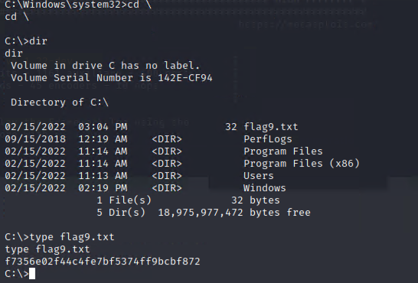

15. Red Pill was then able to use KIWI to find the NTLM Hash to the user **Administrator** which could then be cracked easily by using john and log in to the user **Administrator** with elevated privileges.

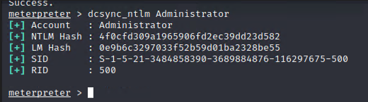

## Summary Vulnerability Overview

|  |  |
| --- | --- |
| **Vulnerability** | **Severity** |
| SQL Injection Vulnerability | **High** |
| File Inclusion Vulnerability | **High** |
| PHP Injection Vulnerability | **High** |
| XSS Vulnerability | **High** |
| Weak Passwords | **Critical** |
| Allowing traffic through open ports | **Critical** |
| Outdated Software and Ports | **Critical** |
| Unnecessary scheduled tasks | **High** |
| Publicly available sensitive information | **Critical** |
| Non encrypted HTTP cleartext | **High** |
| Sensitive information stored in easily accessible files | **Critical** |
|  |  |
|  |  |
|  |  |
|  |  |
|  |  |
|  |  |
|  |  |
|  |  |
|  |  |
|  |  |

The following summary tables represent an overview of the assessment findings for this penetration test:

|  |  |
| --- | --- |
| **Scan Type** | **Total** |
| Hosts | 192.168.14.35 (Web App)  192.168.13.10 (Linux machine)  192.168.13.11 (Linux machine)  192.168.13.12 (Linux machine)  192.168.13.13 (Linux machine)  192.168.13.14 (Linux machine)  172.22.117.20 (Windows 10 Machine)  172.22.117.10 (Windows Domain Controller) |
| Ports | 8009, 8080, 80, 22  (Linux)  21, 25, 79, 80, 106, 110, 135, 139, 443 (Windows) |

|  |  |
| --- | --- |
| **Exploitation Risk** | **Total** |
| **Critical** | 3 |
| **High** | 3 |
| **Medium** | 6 |
| **Low** | 1 |

## Vulnerability Findings

|  |  |
| --- | --- |
| **Vulnerability 1** | **Findings** |
| **Title** | SQL Injection Vulnerability |
| **Type (Web app / Linux OS / WIndows OS)** | Web App |
| **Risk Rating** | **High** |
| **Description** | Red Pill was able to access sensitive information on the Rekall Corporation’s Web App by creating malicious payloads using SQL which when input into the Web App, return an output of sensitive information. |
| **Images** |  |
| **Affected Hosts** | 192.168.14.35 |
| **Remediation** | Input Validation  Least Privilege Principle  Parameterized Queries  Web Application Firewalls |

|  |  |
| --- | --- |
| **Vulnerability 2** | **Findings** |
| **Title** | File Inclusion Vulnerability |
| **Type (Web app / Linux OS / WIndows OS)** | Web App |
| **Risk Rating** | **High** |
| **Description** | Red Pill was able to upload a malicious script file into the Web App only by by putting ‘jpg’ in the name of the file and not the extension, to bypass input validation. Using this script, Red Pill was able to access sensitive information. |
| **Images** |  |
| **Affected Hosts** | 192.168.14.35 |
| **Remediation** | Input Validation  Whitelisting  Restricted File Permissions  Web Application Firewalls |

|  |  |
| --- | --- |
| **Vulnerability 3** | **Findings** |
| **Title** | Non encrypted HTTP cleartext |
| **Type (Web app / Linux OS / WIndows OS)** | Web App |
| **Risk Rating** | **High** |
| **Description** | Red Pill was able to sniff HTML cleartext being transmitted and access sensitive information in the HTML cleartext. |
| **Images** |  |
| **Affected Hosts** | 192.168.14.35 |
| **Remediation** | Encryption |

|  |  |
| --- | --- |
| **Vulnerability 4** | **Findings** |
| **Title** | XSS Vulnerability |
| **Type (Web app / Linux OS / WIndows OS)** | Web App |
| **Risk Rating** | **High** |
| **Description** | By exploiting the XSS vulnerability present in the Web App, Red Pill was able to create malicious script payloads and use them to access sensitive information. |
| **Images** |  |
| **Affected Hosts** | 192.168.14.35 |
| **Remediation** | Output Encoding  Input Validation  Content Security Policies |

|  |  |
| --- | --- |
| **Vulnerability 5** | **Findings** |
| **Title** | Weak Passwords |
| **Type (Web app / Linux OS / WIndows OS)** | Web App, Linux OS, Windows OS |
| **Risk Rating** | **Critical** |
| **Description** | Red Pill was able to crack most of the username passwords very easily, which shows the very weak password policies have been set. |
| **Images** |  |
| **Affected Hosts** | 192.168.14.35 (Web App)  192.168.13.10 (Linux machine)  192.168.13.11 (Linux machine)  192.168.13.12 (Linux machine)  192.168.13.13 (Linux machine)  192.168.13.14 (Linux machine)  172.22.117.20 (Windows 10 Machine)  172.22.117.10 (Windows Domain Controller) |
| **Remediation** | Set strong password policies.  Password should be changed regularly.  MFA (Multi-Factor Authentication)  User Training and Awareness Programs |

|  |  |
| --- | --- |
| **Vulnerability 6** | **Findings** |
| **Title** | Allowing traffic through open ports |
| **Type (Web app / Linux OS / WIndows OS)** | Linux OS, Windows OS |
| **Risk Rating** | **Critical** |
| **Description** | Red Pill was able to find and scan ports using nmap against the hosts and further use Kali and metasploit to exploit the open ports found on the machine to perform various exploits and reveal sensitive information. |
| **Images** | *Linux hosts and open ports*    *Windows 10 host and open ports* |
| **Affected Hosts** | 192.168.13.10 (Linux machine)  192.168.13.11 (Linux machine)  192.168.13.12 (Linux machine)  192.168.13.13 (Linux machine)  192.168.13.14 (Linux machine)  172.22.117.20 (Windows 10 Machine)  172.22.117.10 (Windows Domain Controller) |
| **Remediation** | Strong Firewall Configuration  Close Unnecessary ports  Continuous Monitoring and Port Scanning  Network Segmentation |

|  |  |
| --- | --- |
| **Vulnerability 7** | **Findings** |
| **Title** | Outdated Software and Ports |
| **Type (Web app / Linux OS / WIndows OS)** | Linux OS, Windows OS |
| **Risk Rating** | **Critical** |
| **Description** | Red Pill was able to conduct port scanning and find information regarding what vulnerabilities do the current port versions have and using this information, Red Pill was able to exploit these vulnerabilities. |
| **Images** |  |
| **Affected Hosts** | 192.168.13.10 (Linux machine)  192.168.13.11 (Linux machine)  192.168.13.12 (Linux machine)  192.168.13.13 (Linux machine)  192.168.13.14 (Linux machine)  172.22.117.20 (Windows 10 Machine)  172.22.117.10 (Windows Domain Controller) |
| **Remediation** | Patch Regularly  Vulnerability assessment  Network Segmentation  Continuous Improvement |

|  |  |
| --- | --- |
| **Vulnerability 8** | **Findings** |
| **Title** | Unnecessary scheduled tasks |
| **Type (Web app / Linux OS / WIndows OS)** | Windows OS |
| **Risk Rating** | **High** |
| **Description** | Red Pill was able to find multiple unnecessary scheduled tasks which Red Pill can use to mask malicious scheduled tasks for persistence. |
| **Images** |  |
| **Affected Hosts** | 172.22.117.20 |
| **Remediation** | Scheduled task review  Monitoring tasks  Automated task management |

|  |  |
| --- | --- |
| **Vulnerability 9** | **Findings** |
| **Title** | Publicly available sensitive information |
| **Type (Web app / Linux OS / WIndows OS)** | Linux OS, Windows OS |
| **Risk Rating** | **Critical** |
| **Description** | Red Pill was able to Domain Dossier tool against the hostname totalrekall.xyz and find sensitive information and Red Pill was also able to access Rekall github repository and find credentials. |
| **Images** |  |
| **Affected Hosts** | 192.168.13.10 (Linux machine)  192.168.13.11 (Linux machine)  192.168.13.12 (Linux machine)  192.168.13.13 (Linux machine)  192.168.13.14 (Linux machine)  172.22.117.20 (Windows 10 Machine)  172.22.117.10 (Windows Domain Controller) |
| **Remediation** | Encryption  Access control  Data Masking  Monitoring and Auditing |

|  |  |
| --- | --- |
| **Vulnerability 10** | **Findings** |
| **Title** | Sensitive information stored in easily accessible files |
| **Type (Web app / Linux OS / WIndows OS)** | Windows OS |
| **Risk Rating** | **Critical** |
| **Description** | Red Pill was able to find several files on the host machines which contained sensitive information that could be exploited. |
| **Images** |  |
| **Affected Hosts** | 172.22.117.20 (Windows 10 Machine)  172.22.117.10 (Windows Domain Controller) |
| **Remediation** | Encryption  Access control  Monitoring  User training and awareness programs |